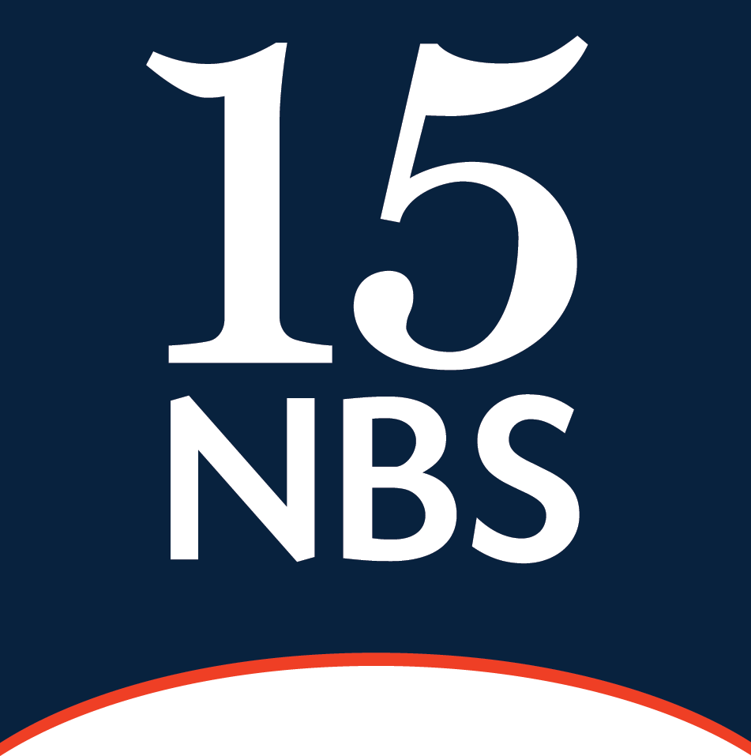
Clodaghmuire Callinan

YEAR OF CALL: 2007

Clodaghmuire is a criminal defence advocate specialising in serious violence, firearms and drugs. She has been instructed as junior alone in a range of cases such as kidnap, multi- handed drugs conspiracies, child neglect, rape, witness intimidation and allegations of vio- lence at all levels. She has held leading briefs in multi-handed conspiracies and immigration offences.

She has represented in every type of dishonesty offence, including fraud, burglary, robbery, obtaining by deception, money laundering, possessing and using fraudulent identity docu- ments and counterfeit currency.

Clodaghmuire is particularly adept at cases with matters of law such as abuse of process, fit- ness to plead, trial of issue, applications to dismiss, section 76/78 PACE, section 41 YJPCEA, bad character and hearsay.

She is extremely computer literate and therefore able to manage cases with large volumes of evidence efficiently and in a client friendly manner.

NOTABLE CASES

Firearms

R v B & Others - Armed robbery of cash-in-transit vans using guns.

R v G & Others - Firearms case successfully arguing exceptional circumstances due to age and illness.

R v S - Firearms case where appointed to cross-examine. Identified that ID evidence was in- sufficient and self-defence raised as section 16 offence.

R v A - Application to dismiss on the basis of ID evidence in breach of PACE.

R v M - Firearms case successfully arguing exceptional circumstances due to mental capabili- ties.

R v M & Others - Firearms case successfully argued that just because ammunition in gun when found, did not mean necessarily in possession of it.

R v W & Others - Multi-handed firearms conspiracy/manufacturing. Limited IQ hindering ability to form the intent to endanger life.

R v B & Others - Multi-handed conspiracy to supply firearms.

Drugs

R v K & Others - County lines multi-handed drugs conspiracy running the defence of duress.

R v S & Others - Family drugs and money laundering operation. R v C - Undercover drugs operation running the defence of duress. R v U - Drug supply. Successfully overturned conviction

Violence

R v S & Others - Multi-handed drug related conspiracy to kidnap and section 18. Successful- ly excluded telephone evidence due to late service.

R v E & Others - Multi-handed debt related kidnap involving a substantial amount of tele- phone and ANPR evidence.

R v R - Section 18 involving slashing complainant’s neck with a machete in self-defence.

R v W - Arson with intent to endanger life.

Sexual Offences

R v S - Child sex doll case.

R v M - Rape and coercive behaviour. Crown offered no evidence after cross-examination.

R v F - Rape. Judge allowed cross-examination on failure of complainant to take oath.

Fraud

R v B & Others - Multi-handed large-scale fraud involving immigration offences.

R v M & Others - Large-scale puppy farm fraud.

R v H - Fraud from the UKBA

PRO BONO INTERESTS

2 days living on the street as a homeless person for Muslim Youth. Net, raising awareness through an educational DVD of what life is really like on the streets, targeting the increasing number of young Muslims who run away from home.

Skydive for the charity Community Links.

Volunteer at Bow County Court Advice Service – representing clients at possession/warrant hearings.

Disability Living Allowance cases for Community Links.

Immigration case for a client of Body & Soul, who support children who are HIV positive. Training to box for a charitable boxing match for YourStory/Fitzroy Lodge Boxing Club.

QUALIFICATIONS
LLB (Hons) Law & Politics - University of Buckingham LLM - Trinity College Dublin

PROFESSIONAL ASSOCIATIONS
Criminal Bar Association South Eastern Circuit

