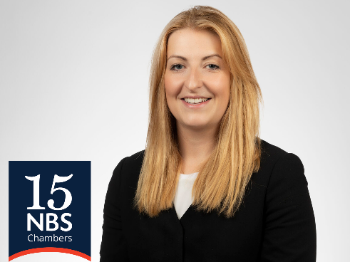

HELEN DAWSON
YEAR OF CALL: 2014

Helen is regularly instructed as a junior alone and as a led junior in a wide range of criminal offences, which are often of a serious and complex nature, including murder, firearms, drugs’ conspiracies and rape.
Helen is known for her high level of attention to detail, particularly in the preparation of her cases and for her ability to build a good rapport with her clients, especially those who are young and/or vulnerable, making her a formidable advocate. Her approach complements her interest in fraud and confiscation proceedings, which often involve substantial sums of money and are complicated by features such as interests of third parties or cross-jurisdictional issues. Helen has previously undertaken a secondment at the Financial Conduct Authority and receives instructions from the Serious Fraud Office.
In January 2025, Helen was appointed to the List of Specialist Regulatory Advocates at the Category B level. She can now accept instructions on behalf of The Health and Safety Executive, The Environment Agency, the Office of Rail and Road, Natural Resources Wales, the Care Quality Commission and the Office for Product and Safety Standards.
Helen also has an established practice representing individuals charged with offences relating to football disorder and defending against the imposition of Football Banning Orders.

NOTABLE CASES

R v C – Instructed as a led junior to represent a defendant alleged to have being involved in cheating the Revenue. The estimated loss to the Revenue of £21 million. Matter is ongoing. (VHCC)

LBC v N – Instructed to represent N, who is alleged to have participated in a procurement fraud, involving public funds. Matter is ongoing.

R v H – Instructed to prosecute H, a former serving Police Officer, for child sexual offences.

R v O – Instructed to represent a defendant who is alleged to have established a drugs’ network on the dark web selling multiple different types of drugs and then traded in Bitcoin. W was charged with 15 counts of conspiring to supply classified drugs. Following an successful application to dismiss in respect of five counts, W was acquitted of six counts after trial and was found to be in a ‘lesser’ role, in respect of sentencing for the remaining four counts.

R v H – Instructed to represent a defendant who is alleged to have engaged in money laundering connected to a large-scale drugs’ conspiracy, known as Operation Friction, in which the H’s partner and others, were profiting in excess of £20, 000 per day. H was acquitted after trial.

R v A & Others – Instructed as a led junior to prosecute a multi-handed conspiracy to murder and possession of a firearm with intent to endanger life. Defendants were convicted after trial.

R v F – Instructed on behalf of a defendant charged with possessing an imitation firearm, which was fired at two youths, waiting at a nearby bus stop.

R v F – Led junior, instructed to represent a defendant charged with conspiring to supply Class A drugs, involving telephone downloads, some of which were encrypted, Encrochat phones and covert observations. Trial lasted eight months.

R v W – Instructed on behalf of a defendant charged with causing the death of a pedestrian by careless driving. Despite significant aggravating factors, JW received a sentence of 18 months’ imprisonment. (Reported here https://metro.co.uk/2023/01/30/london-speeding-driver-who-killed-dad-of-two-in-hit-and-run-jailed-18191028/)

R v T – Instructed to prosecute a defendant charged with making a threat to kill, trespass to commit a sexual offence and assault. Psychiatrists instructed on behalf of the Prosecution and Defence gave evidence at trial, which led to a finding by the jury that the Defendant was ‘not guilty’ by reason of insanity. Extensive pre-trial advisory work was required, including the instruction of the expert.

R v IB - Instructed to represent a young defendant charged with kidnap, false imprisonment, controlling and coercive behaviour and assault. Defendant was acquitted of all counts after trial.

R v S – Led junior, instructed to represent a defendant charged with participating in a conspiracy to steal, predominantly concerning plant machinery, vehicles and ATMs. Included an allegation of involvement in theft of heritage value trophies from the National Horse Racing Museum. A wide-ranging investigation covering several counties, encompassing cell-site, telephone downloads including telephonic activity and CCTV footage. Defendant was acquitted of a count relating to the National Horse Racing Museum after jury failed to reach a verdict. (reported https://www.bbc.co.uk/news/uk-england-oxfordshire-61506692)

OTHER EXPERIENCE

Before coming to the Bar, Helen worked in the House of Commons, as a researcher for a Member of Parliament, gaining experience of working on campaigns at a local and national level.

QUALIFICATIONS AND AWARDS

Law with Legislative Studies LLB (Hons) – University of Hull Bar Professional Training Course – Kaplan Law School Sweet and Maxwell Pupillage Award – Inner Temple Criminal Bar Association Bursary

PROFESSIONAL ASSOCIATIONS & POSITIONS

Specialist Regulatory Advocates Panel - Category B
CPS Grade 3 Prosecutor
CPS Specialist POCA Prosecutor
Criminal Bar Association
Fraud Lawyers Association
Female Fraud Forum
Qualifying Sessions Sub-Committee – Inner Temple Criminal Bar Association Education Sub-Committee

PUBLICATIONS

“Government giving football fans the red card? Changes in the law surrounding Football Banning Orders” August 2022

“Disclose me the money: the ever expanding powers of disclosure orders” – Young Fraud Lawyers Association Spring Newsletter 2017

